FTIR experiment – May 1st 2017

Tasks:

1. Learn to use the machine and software by doing some basic scans
2. Get 5 scans of **water**, **bacteria** and **bacteria diluted 1:100.**
3. Get scan of dried surface after **water** and after **bacteria**

# Part 1

Background:

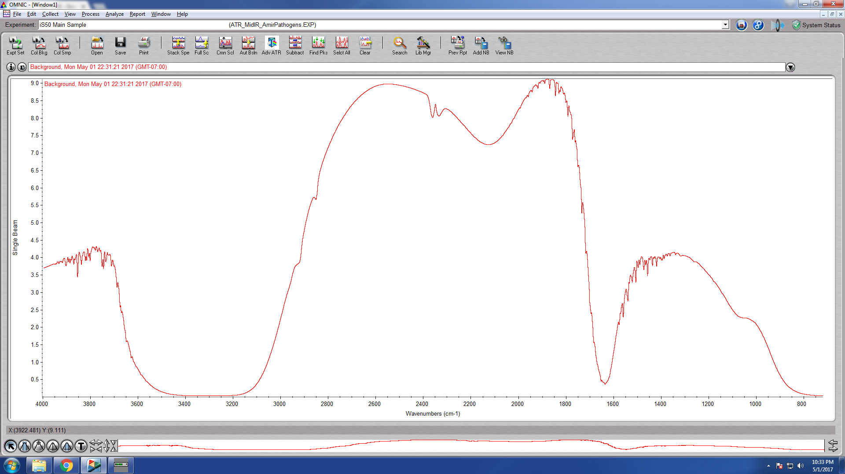

Water 10:33:

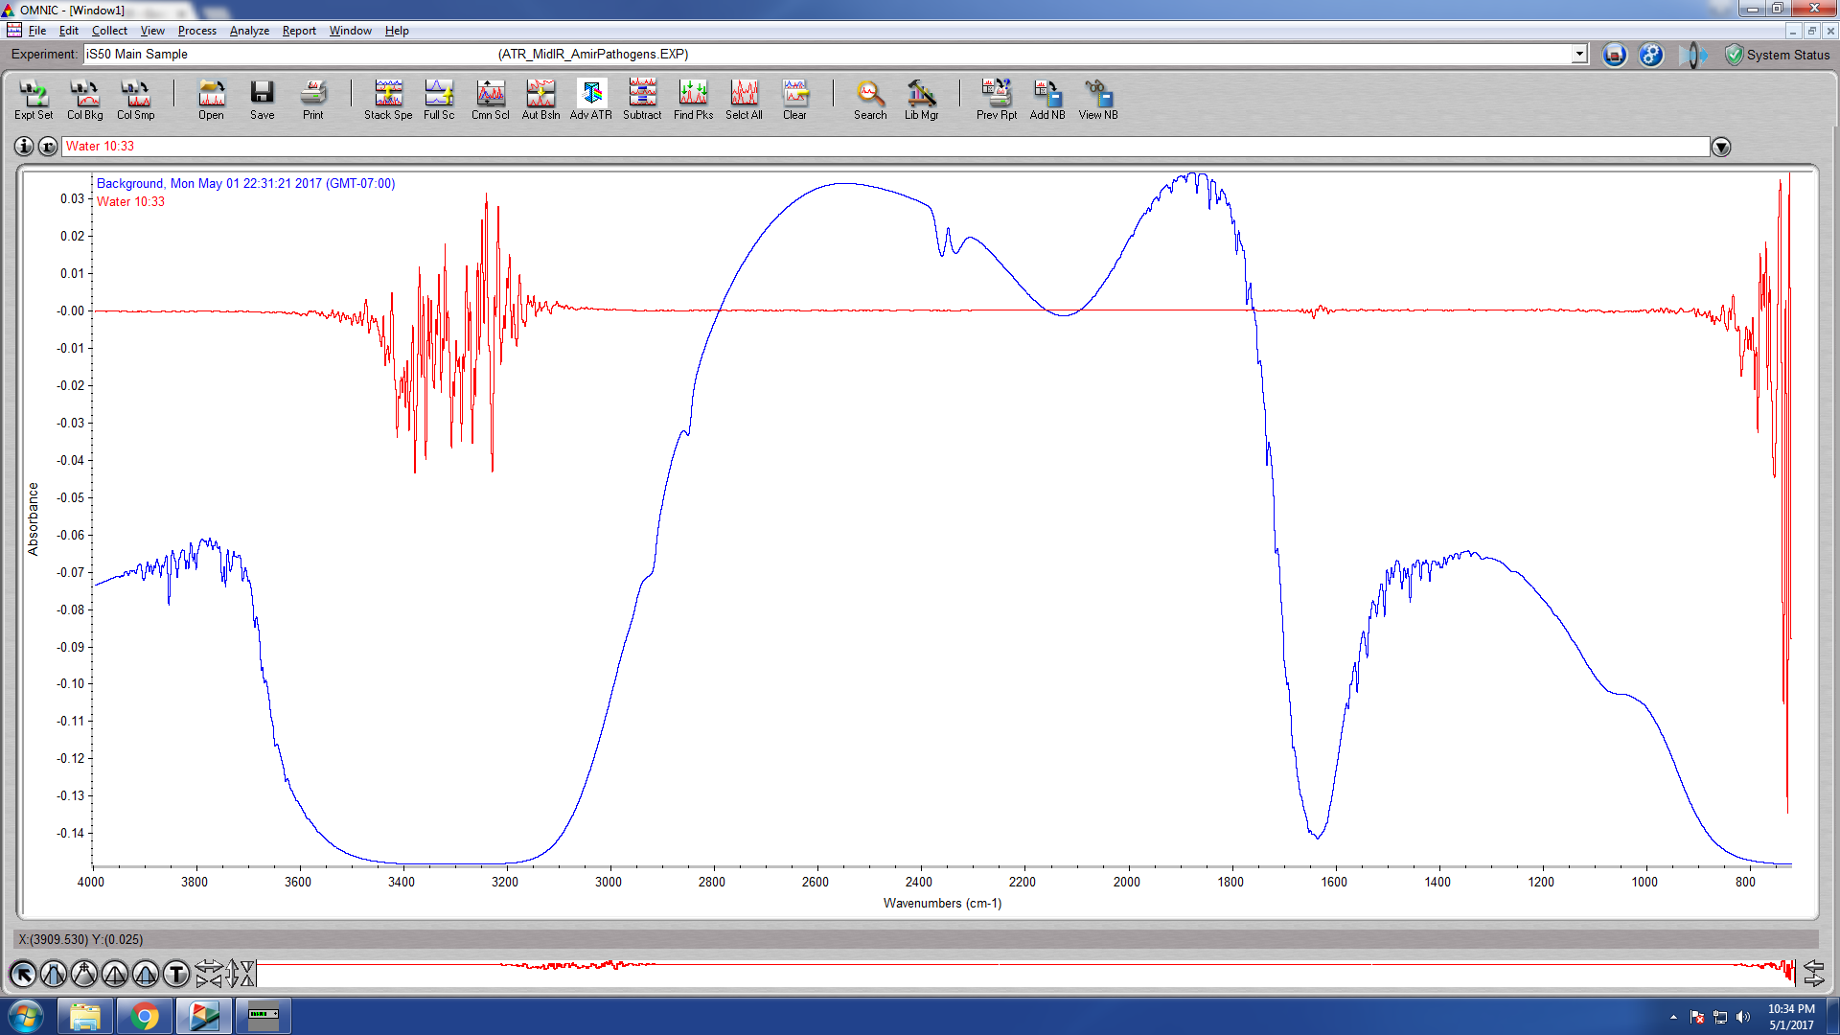

Note - The noise is only in the “dead” regions of the background - possible this is just machine noise…

Bacteria @1:100 vs water

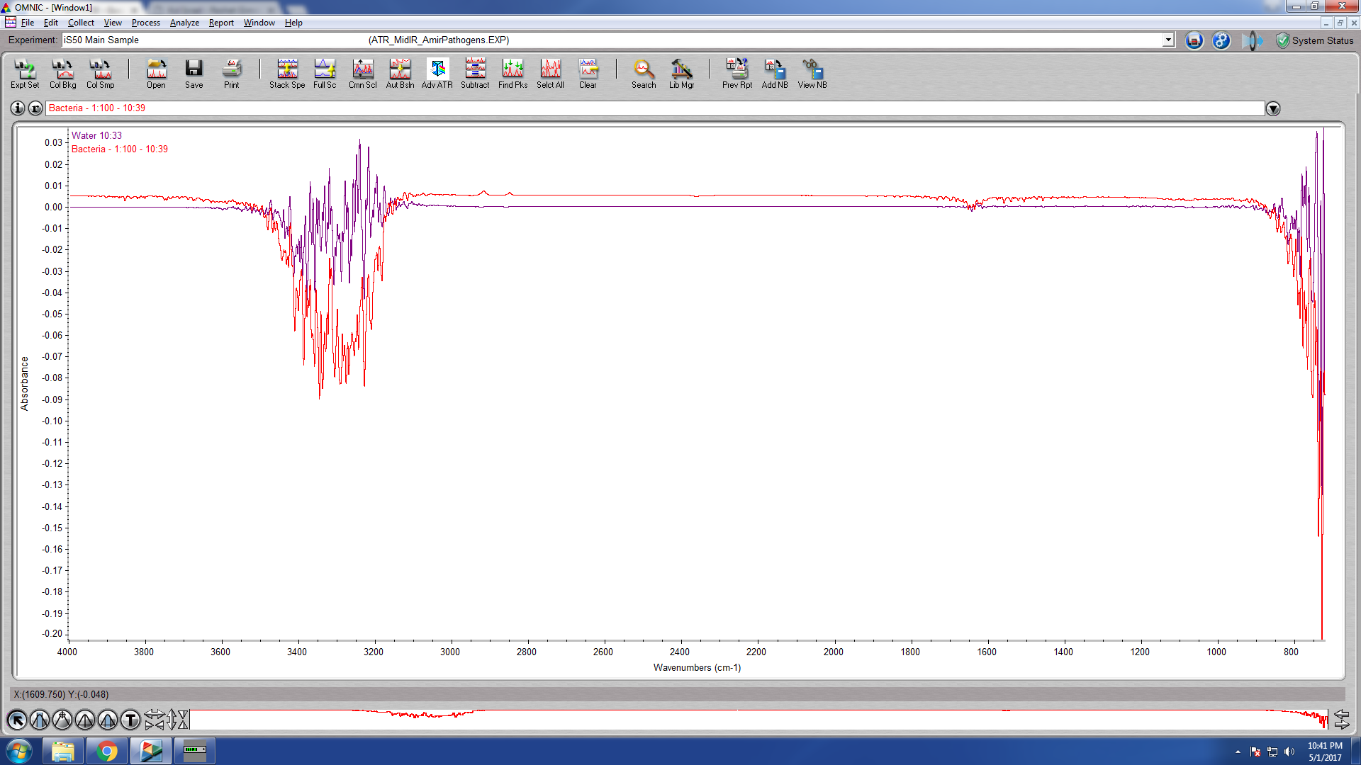

After cleaning with EtOH - water

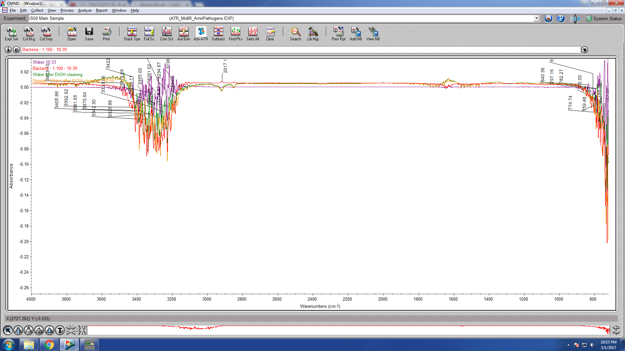

Bacteria 1:1

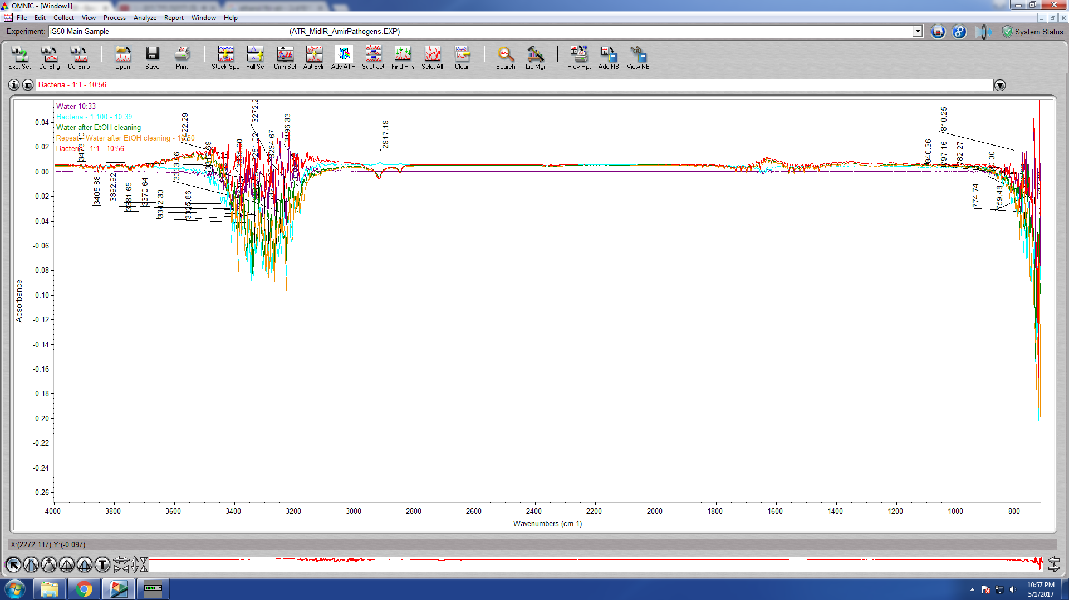

# Experiment 1 - 5 scans for statistics – Bacteria in Solution

Protocol:

* Clean twice with EtOH and wipe with cotton wool.
* Sample size: 600uL, spread evenly.
* Surface temp 38C Room temp 23C (aircon)
* Purge delay 20s
* 32 scans
* Gain = 8
* Door closed. Alone.

Note – scan takes 1:15m

Scans:

5 x Water

5 x Bacteria (~108 CFUs/ml)

5 x Bacteria diluted 1:100

11:14 - cleaned with EtOH and took Water Background

Finished scanning: 12:14

Note – scan Water 2 and Water 2* were strange and taken off analysis.

**PLS diagnostic**:

Done with JMP. PLS of 14 samples.

Validation: Leave-One-Out

Factors: 8

Blue – water

Yellow – diluted bacteria (defined as 0.8 for JMP)

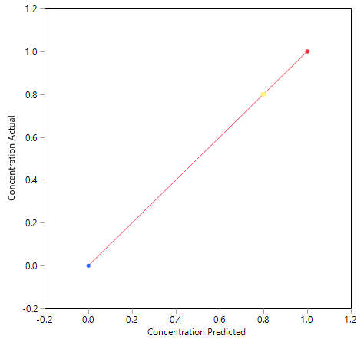Red - Bacteria

# Experiment 2 - Scan dry

Changed the surface temp to **60C**.

Cleaned with ethanol and let evaporate.

Evaporated water as background. Evaporation takes 25-35 minutes.

